# Over the Wire: Bandit

Bandit0

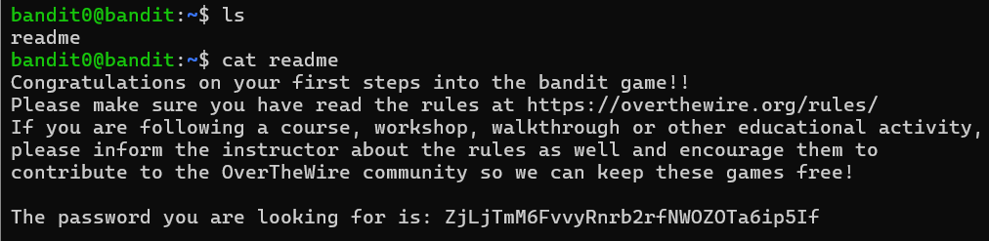

Bandit Level 1 → Level 2

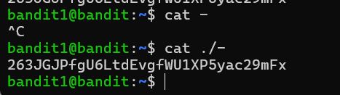

Bandit Level 2 → Level 3



Bandit Level 3 → Level 4

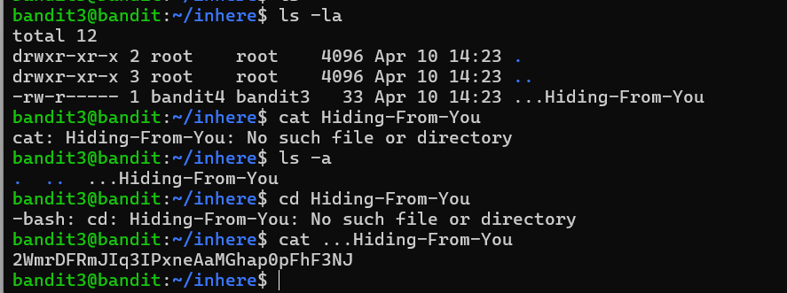

Bandit Level 4 → Level 5

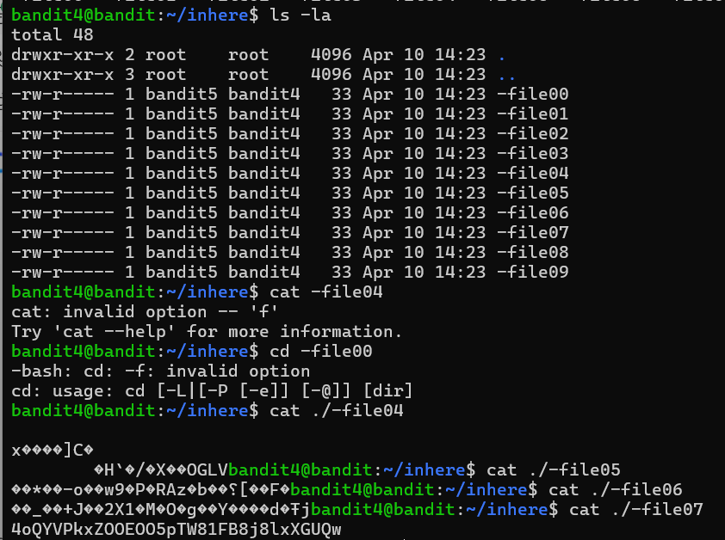

Bandit Level 5 → Level 6

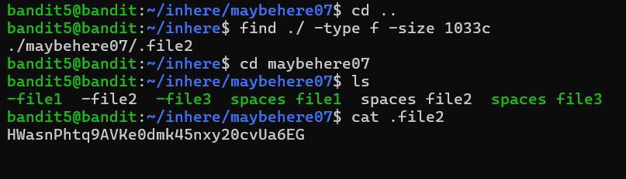

Bandit Level 6 → Level 7

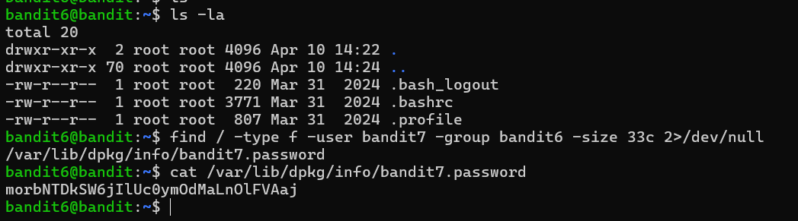

Bandit Level 7 → Level 8

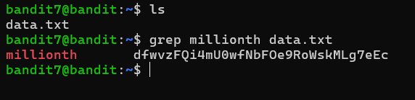

Bandit Level 8 → Level 9

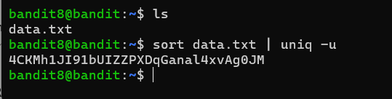

Bandit Level 9 → Level 10

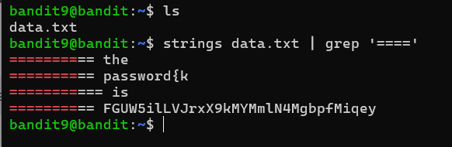

Bandit Level 10

